ANLY 503 Assignment 2

Christopher Fiaschetti

6/20/2020

## Introduction

The most popular sport in the world is football/soccer. Every four years, 32 of the globe’s best countries, soccer-wise, congregate to compete and see who has produced the best group of footballers. This is known as the FIFA World Cup. It is a grand event that takes place over a month. During the years preceeding the world cup, countries go through qualifying stages to see if they are worthy to compete in the tournament. Some years, like 2018 for the USA, a nation could see their team fall in the last round of the qualifiers and have to wait another five years to possibly see their team compete in the world largest sporting competition.

Once qualified, Teams start in group stages. Four countries to a group and they all play each other once. They recieve three points for a win, one each for a tie, and none for a loss. After the teams play each other, the top two teams from each group advance into knockout rounds until a champion is eventually crowned. Youth footballers dream of one day scoring the winner in the final match. As of 2020, Brazil has accumulated the most championships (5). Germany and Italy are tied for the next most with 4 each, followed by Urugauy, Argentina, and the most recent champion (France) with 2 apiece.

Prior to the 2018 world cup, fivethirtyeight took it upon themselves to simulate and predict how that world cup would go. Of course, everyone wants to know who the eventual winner would be. Bettors look to make a quick buck on some bets, while fans want to know how much emotional value they should invest into their team’s campaign. National economies also are interested in this metric. If a country is expected to be good, that could mean an increase in tourism, parades for victories, babies concieved (seriously, there’s been some correlation between country success and conception rates - <https://foreignpolicy.com/2017/03/28/icelands-historic-baby-boom-comes-nine-months-after-surprise-euro-cup-2016-win-soccer-football-sports-birth-rates/>), merchandise for the country and publicity overall, just to name a few things. As such, countries must be adequately prepaired for victories and successes.

Overall, an analysis of fivethirtyeight’s predictions for the 2018 World Cup will be completed. It is anticipated that all metrics and types of predictions will point to the same level of success for each team.

# About the Data

The data comes from fivethrityeight’s open source data repository. There are 20 parameters and 256 rows of data in the dataset. Please find a list of parameters with description below:

|  |  |
| --- | --- |
| **Parameter** | **Description** |
| forecast_timestamp | Date the given prediction was run |
| team | Name of the country that the prediction is about |
| group | Group the team was put into for the 2018 World Cup |
| spi | Soccer Power Index associated with the given team |
| sim_wins | Number of simulated wins from fivethirtyeight prediction |
| sim_ties | Number of simulated ties from fivethirtyeight prediction |
| sim_losses | Number of simulated losses from fivethirtyeight prediction |
| sim_goal_diff | Goal differential form from fivethirtyeight prediction |
| goals_scored | Number of simulated goals scored from fivethirtyeight prediction |
| goals_against | Number of simulated goals against from fivethirtyeight prediction |
| group_1, group_3, group_3, group_4 | Binary values indicating which of the groups the given team was associated with based on fivethirtyeight prediction and simulations |
| make_round_of_16, make_quarters, make_semis, make_final, win_league | If not 1 or 0, percent chance the given team makes it out of the given stage. If 1 or 0, indicated if they will make it out or won’t make it out based on projections. |
| timestamp | Publish time of data |

As can be seen in Figure 1, there were eight different forcastings done by fivethirtyeight. The data type was originally Factor for the timestamps. For easier understanding, that has been switched to character and only the date is shown in the bar chart instead of datetime. Each one of them has 32 rows. This means that all 32 countries that participated in the 2018 World Cup should have 8 records each of prediction.



*Figure 1:* The number of countries that 538 predicted for in each of their predictions.



*Figure 2:* The number of unique countries that had predictions associated with them.

However, there are some issues that, as can be seen in Figure 2. Not all countries have 8 predictions. There are some missing values as well as values such as “Apple”, “Bannana”, “Not Brazil”, and even “12” for some of these records. As such, we cannot work with them and should remove them from our dataset.



*Figure 3:* The number of countries that 538 predicted for in each of their predictions after first round of data cleaning.

After cleaning the data, there are now missing 12 records from the first prediction, as is depicted in Figure 3. From there, 2018-06-13 predictions were analyzed more. Just from looking at the head of the data in Figure 4, it can be seen that there are issues with the data. There are missing values in global_d and sim_wins. Additionally, there is a value for sim_ties that says, “Hi Tom!”. Weird! That column is also a factor, when it needs to be numeric. Adjustments were necessary.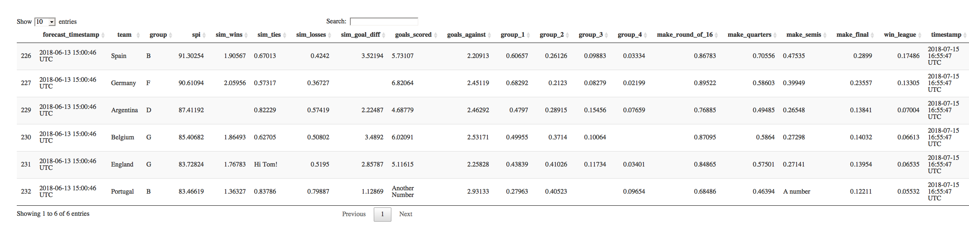

*Figure 4:* The first six complete records associated with 2018-06-13 predictions. Missing values and errors in data highlighted in red circles. ­

After adjusting for complete cases of the group, there are only 9 rows left. The type of response was analyzed to makes sure the data was properly stored and would be useful to collecting insights.

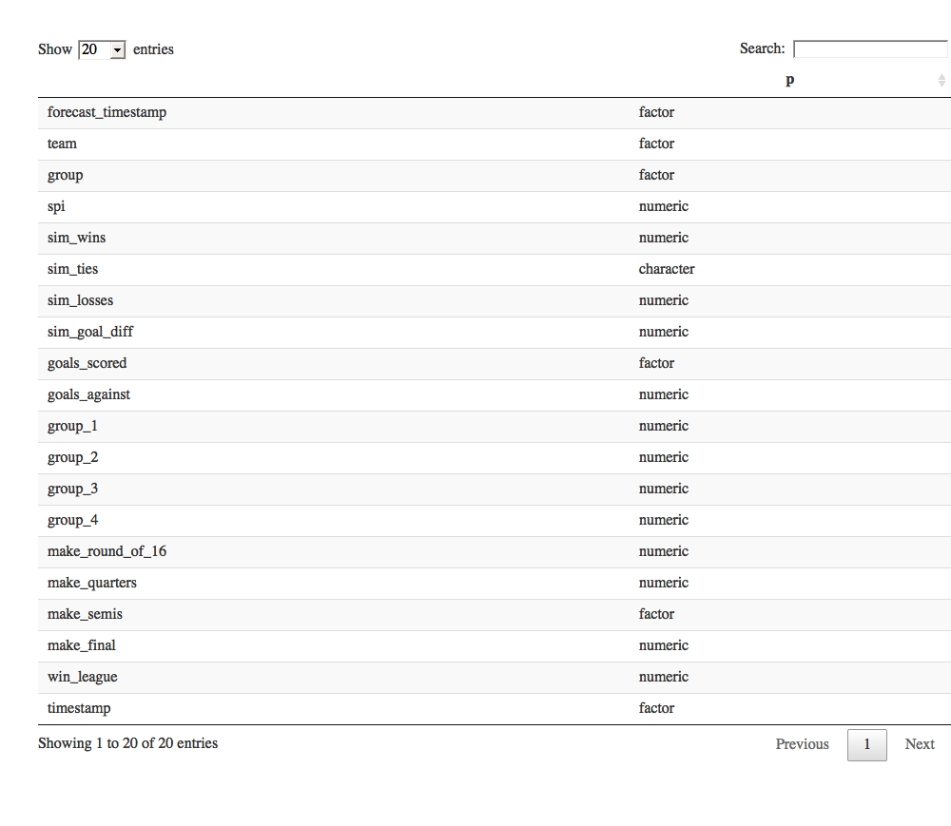

*Figure 5:* The types of each parameter in the data frame to this point in the data cleaning.

As can be seen in Figure 5, sim_ties, goals_scored, and make_semis were still of type Factor, when they should be numeric. Adjustments needed to be made with not only the type, but also what was in the records. Mentioned earlier in regard to Figure 4, some records like “Hi Tom!” and “Another Number” are errors in the data. Those records needed to be removed. As such, there were only eight valid rows left from the 2018-06-13 predictions and it was determined that the said predictions were not useful and should be thrown out. This can be seen in Figure 6.



*Figure 6:* The number of countries that 538 predicted for in each of their predictions after second round of data cleaning.

There were still some columns as factors that should be numeric or character. As such, adjustments needed to be made and were. Additionally, columns such as “timestamp” were removed, as no insights were provided from them. With forecast_timestamp, team, group, spi, sim_ties, goals_scored, make_semis and timestamp cleaned or removed, the remaining parameters needed to be addressed.

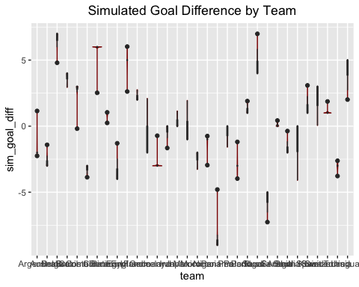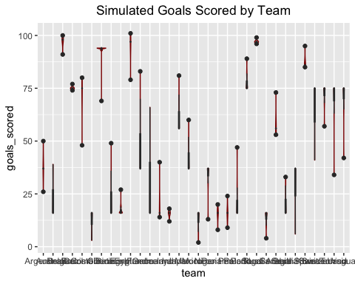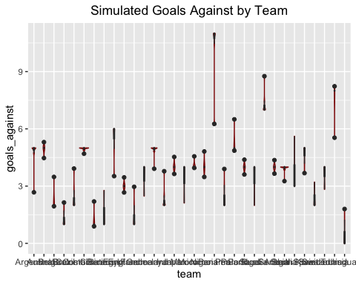

*Figure 7:* Violin plots of each counties predicted (from left to right) simulated goal difference, simulated goals scored and simulated goals against.

In Figure 7, violin plots for the simulated goal difference, goals scored, and goals against can be seen. A few insights can be gleaned here. First, it shows that the different similations produced different numbers each time. Otherwise, there would only be dots at one location for each team. This is good to know that everything was different in the predictions. Fivethirtyeight did not simply rerun the same test over and over. They made new models and adjusted. Next, it can be seen how goal difference can be different for certain types of teams. A highly positive goal difference can come from medium goals scored and low goals against or high goals scored and medium goals against. This is significant from a results standpoint.

Furthermore, it was important to understand the distribution of the Soccer Power Index (SPI) associated with each team.



*Figure 8:* Histogram of teams’ SPI

The high spike in the middle of the SPI histogram in Figure 8 and tails on either side show that the distribution tends to be normally distributed. However, the data is slightly left-skewed. This makes sense from a soccer fan perspective, as there are a number of countries in the middle level of talent, as well as a number of powerhouses, and not a ton of “completely horrible” teams. Additionally, the data is in regard to World Cup participants. Those competing in the World Cup already have been deemed as the top 32 teams just by qualifying. With the level of teams in mind, the number simulated wins was analyzed.

 

*Figure 9:* Histograms of Simulated Wins in the predictions. Left – only 6 bins. Right – 12 bins.

The importance of binning histograms accurately was impressed upon the data scientist working on the project, as the left histogram in Figure 9 doesn’t completely show what needs to be shown by the data. With the number of bins adjusted to 12 to emphasize the large number of complete numbers, clearer distinctions can be made between the number of simulated wins predicted. This led to the insight that the two earliest dates have decimal places, while the later five dates are whole numbers.

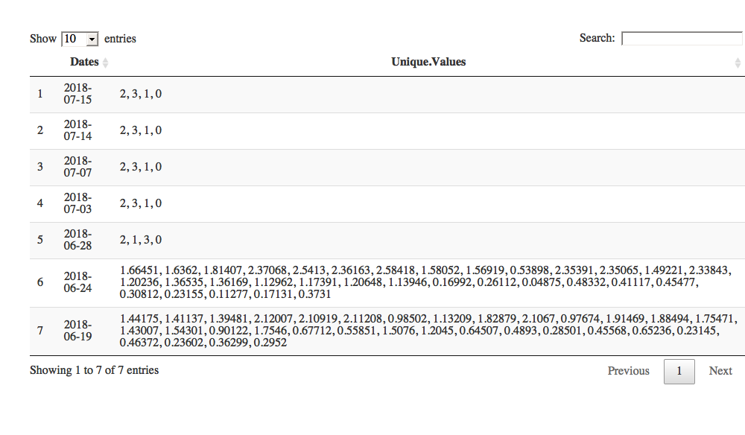

*Figure 10:* The unique values for Simulated Wins associated with each prediction date

## Results

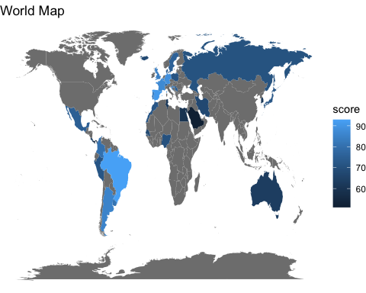

*Figure 11:* World Map colored by SPI. Countries with brighter blues have higher SPI’s, while countries with darker blues have lower SPI’s.

Figure 11 shows not only which countries made the World Cup in 2018, but also colors them by their average SPI for each of the projections done by fivethirtyeight. The lighter the color, the better the country. As we can see, African countries that made it were not very good. Niether were North American countries (Mexico). The samge goes for Austrialia and Asia. The best countries come from South America and Europe. This is interesting given the sizes of the countries. America, Canada and Russia either did not make the World Cup, indicating they do not have high SPI’s and are not colored, or are reported and do not have high SPI scores, while England, Spain, Italy, Germany, and other small European countries do. There has been much talk over the years about why this is. In terms of America, the general consensus is that it is a result of the dimished importance and glory associated with soccer in the country.

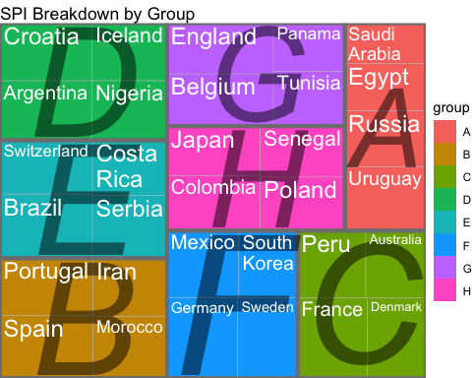

*Figure 12:* Treemap of Groups and Teams in the 2018 World Cup by SPI

Figure 12 depicts a tree map for the average SPI by group in the 2018 World Cup. The best countries, like the best groups, account for more area in the treemap. It can be seen from the treemap that the worst group is group A by SPI. Additionally, we can see that groups D, E, and B are the best groups. F and C are also good, while H and G are better than A but not as good as the rest. The subgroups of pretty much all of the groups are the same. Two teams that are noticeably better than the others. Group H appears to be the most even group, SPI wise. The biggest point here is that there is no “Group of Death”, where there are three powerhouse teams and only two will advance. If there were, a group box would have three teams taking up around 90% of the area, while the other team takes up the remaining 10%.

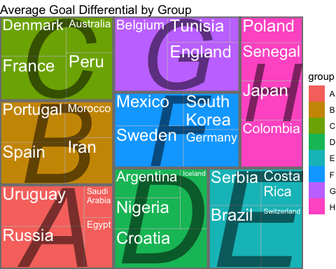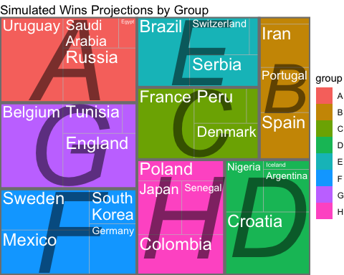

*Figure 13:* Treemaps of Groups and Teams in the 2018 World Cup by average goal differential (left) and simulated Wins (right).

What can be gleaned from the treemap in Figure 12 and the two in Figure 13 is that SPI is not an end-all be-all. By SPI, groups D, B, and E are the best overall groups. By goal difference, only B is one of the top three. However, in the average wins projected via fivethirtyeight simulations shows that group as the worst group overall. It accounts for the least amount of total projected wins in the seven projections. Meanwhile, group A looks to be the best overall group. While it may look lopsided, the overall area of group A still is in the upper tier of areas covered by groups in the map. As such, teams that do advance from group A are expected to go far in the tournament and perform well. It is projected to have one of the highest goal differentials, as well as the most wins overall. Additionally, C ends up showing better in goal differential than SPI and simulated wins.

It can now be seen that the projections distinguish teams by skill level more. Looking back at group B, we originally saw an even distribution by SPI breakdown. We also see that the average goal differential for each team shows B as one of the better teams. However, we see that total wins does not show them as well. This means the teams will not advance far along but will perform well in the games they win and only lose by a low margin (relative. For the chart, the goal differentials were all made to be at least 1.) The notion of SPI not showing the power of some teams and weakness of others appears throughout the Total Projected Goals by Group graphic. Look at group D for an example. The SPI Breakdown by Group has D as fairly evenly distributed. However, total projected wins shows that Crotia and Nigeria dominate the group. Argentina progresses to the group stages a fair amount as well. Iceland, however, does not progress as a result of the strong teams in the group.

## Analysis

Based on this, a few models were built to predict if a given team makes it out of the group stage or not. Changes such as making it out of the group stage or not 1 or 0 were made. The early projections had a probability in for whether or not a team would make the Round of 16. This will be adjusted to binary and logistic regression will be used. Models for SPI, simulated goal difference and simulated wins were all made, Model diagnostics and figures can be found in the Appendix (A1, A2, and A3, respectively).

The best mode was the Simulated Goal Differential model, as it has an AUC of 0.97 and an AIC of 69.81. The other two models are also show well, as SPI has an AUV of 0.93 and an AIC of 109.02, while wins has an AUC of 0.92 and an AIC of 77.65. The only area that goal difference does worse is in the False Positive Rate. Both SPI and Simulated Wins do better in this regard. All together, this means that the models that fivethirtyeight used to predict advancement into the Round of 16 put more emphasis on a team’s predicted goal differential than their predicted wins or SPI.

Since goal differential is so important to the models, goals scored versus goals against models were evaluated. Figure A.4 in the appendix corresponds with the goals scored model, while Figure A.5 in the appendix corresponds with the goals against model. The goals scored model (AUC = 0.93, AIC = 98.189) shows much better than the goals against model (AUC = 0.83, AIC = 141.42). Additionally, there are less false positives in the goals scored model than the goals against model, making the goals for model superior. This means the goals scored model predicted less teams to make that acutally didn’t make it (according to fivethirtyeight projections) than the goals against model. This makes sense from a football standpoint, as a good team will dominate and be able to come back and score when they are losing in a game. However, a team with a bad offense will let up one goal and lose 1-0, never really having a chance to come back and win. The fivethirtyeight models work this way as well.

Decision Trees were also used to evaluate the prediction job done by fivethirtyeight. The first one constructed was with SPI as the predictor and resulted in four splits and five terminal nodes. There was a 90.45% accuracy rate (9.55% misclassification rate), as well as a root node error of 0.25, associated with this tree, which can be seen in Figure 14.

**SPI Decision Tree**



*Figure 14:* Decision Tree with SPI as the predictor.

Simulated Goal Differential was then applied to the Decision Tree method. This resulted in two splits and three terminal nodes, as can be seen in figure 15. It also had a root node error of 0.25. However, it outperformed the SPI model in accuracy rate by 3.51 percentage points, as the Simulated Goal Differential tree boasted an accuracy rate of 93.96% (6.04% misclassification rate).



*Figure 15:* Decision Tree with Simulated Goal Differential as the predictor.

Finally, Simulated Wins was evaluated. While matching SPI and Simulated Goal Differential in root node error, it fell short in accuracy rate. The three-terminal-node tree in Figure 16 only recorded an 89.22% accuracy rate (10.88% misclassification rate).



*Figure 15:* Decision Tree with Simulated Goal Differential as the predictor.

Again, Simulated Goal Differential proves be the most telling predictor for making it into the round of 16. SPI, and Simulated Wins were closer to Simulated Goals in this than they were in the logistic regression modeling but once again did not surpass Simulated Goal Differential.

The final Machine Learning technique used to evaluate the fivethirtyeight predictions was KNN. The results of held true, as Simulated Goal Differential proved to be the best indicator of advancement into the round of 16, just as it had with Decision Trees and Logistic Regression. As can be seen in Figure 16, models that were cross validated to find the best K for each showed Simulated Goal Differential as having the highest accuracy rate at 90%.

|  |  |  |  |  |  |  |
| --- | --- | --- | --- | --- | --- | --- |
|  | SPI | | Simulated Goal Differential | | Simulated Wins | |
| Accuracy | 86.67% | | 90.00% | | 80.00% | |
|  | Confusion Matrices | | | | | |
|  | False | True | False | True | False | True |
| 0 | 39 | 5 | 44 | 7 | 45 | 17 |
| 1 | 7 | 39 | 2 | 37 | 1 | 27 |

*Figure 16:* Accuracies and Confusion Matrices corresponding to each model.

Altogether, our Machine Learning methods showed that Simulated Goal Difference from fivethirtyeight’s simulations were the most important predictor between itself, SPI and Simulated Wins for whether or not a team would advance to the round of 16 in the 2018 World Cup. As such, SPI rankings are not an end-all be-all for teams and projections.

## Moving Forward

This study could be furthered by integrating the actual results of the 2018 World Cup. It was mentioned that the winner was France, but they only showed fairly well in the predictions. Additionally, Spain was an interesting team, as they lost early on in the tournament. The SPI breakdown showed them in favor, as did the goals difference model. However, fivethirtyeight projected Spain to have viewer wins relative to teams that had similar SPI’s. This ended up happening, as Spain lost in the early stages of the tournament. Additionally, diving into what makes certain countries better than others would make for an interesting study. Whether that be Football heritage, population, coaching, etc. I have my own opinions as a fan, but I would like some concrete evidence from data.

Appendix

**Figure A.1 - SPI Model Information**

|  |  |  |
| --- | --- | --- |
| Logistic Regression Predictor | P-value | AIC |
| SPI | <0.001 | 109.02 |

|  |  |  |
| --- | --- | --- |
| Confusion Matrix | | |
|  | False | True |
| 0 | 38 | 1 |
| 1 | 15 | 36 |

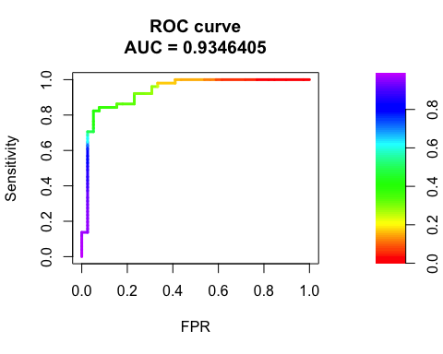

Top – Model diagnostics. Bottom left – ROC Curve. Right – Confusion Matrix

**Figure A.2 – Simulated Goal Differential Model Information**

|  |  |  |
| --- | --- | --- |
| Logistic Regression Predictor | P-value | AIC |
| Simulated Goal Differential | <0.001 | 69.812 |

|  |  |  |
| --- | --- | --- |
| Confusion Matrix | | |
|  | False | True |
| 0 | 29 | 10 |
| 1 | 3 | 48 |

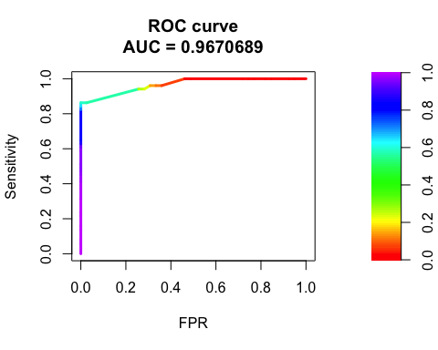

Top – Model diagnostics. Bottom left – ROC Curve. Right – Confusion Matrix

**Figure A.3 – Simulated Wins Model Information**

|  |  |  |
| --- | --- | --- |
| Logistic Regression Predictor | P-value | AIC |
| Simulated Wins | <0.002 | 77.65 |

|  |  |  |
| --- | --- | --- |
| Confusion Matrix | | |
|  | False | True |
| 0 | 37 | 2 |
| 1 | 15 | 36 |

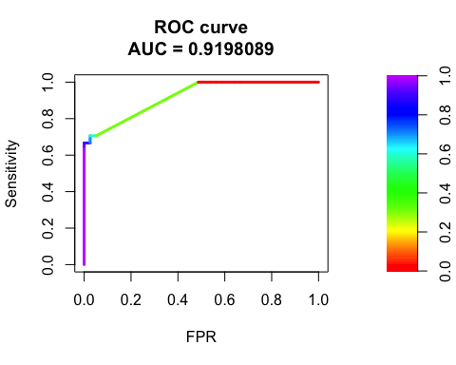

Top – Model diagnostics. Bottom left – ROC Curve. Right – Confusion Matrix

**Figure A.4 – Simulated Goals Scored Information**

|  |  |  |
| --- | --- | --- |
| Logistic Regression Predictor | P-value | AIC |
| Simulated Goals Scored | <0.001 | 98.189 |

|  |  |  |
| --- | --- | --- |
| Confusion Matrix | | |
|  | False | True |
| 0 | 35 | 4 |
| 1 | 12 | 39 |

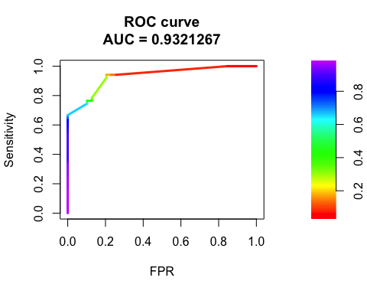

Top – Model diagnostics. Bottom left – ROC Curve. Right – Confusion Matrix

**Figure A.5– Simulated Goals Against Information**

|  |  |  |
| --- | --- | --- |
| Logistic Regression Predictor | P-value | AIC |
| Simulated Goals Against | <0.001 | 141.42 |

|  |  |  |
| --- | --- | --- |
| Confusion Matrix | | |
|  | False | True |
| 0 | 31 | 8 |
| 1 | 19 | 32 |

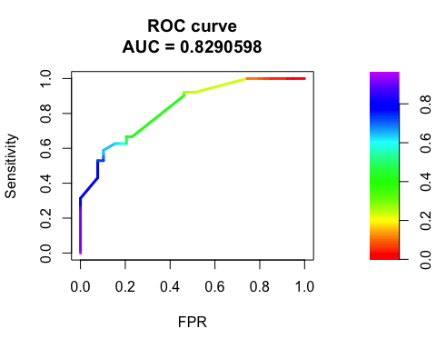

Top – Model diagnostics. Bottom left – ROC Curve. Right – Confusion Matrix